**Artist comes to Oasis Centre**

March, 2012 Nipawin Journal by Rebecca Friesen

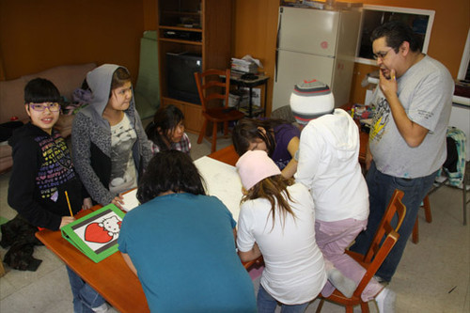

Kevin Pee-Ace made the trip from Saskatoon, who was originally from Yellow Quill First Nations, to work with the kids from the Nipawin Oasis Centre and some seniors as well.

Kevin Pee-Ace made the trip from Saskatoon, who was originally from Yellow Quill First Nations, to work with the kids from the Nipawin Oasis Centre and some seniors as well.

He his a very talented professional artist and he says "It's a very fulfilling profession. You get to do what you love and it gives you the opportunity to get out and work within different groups and communities."

The paintings are usually a four step process where he gets the children to draw their images on a blank canvas, then they outline them with a black marker, color them with bright, vivid colors, and then re-outline the images with black paint to make the picture really pop.

Pee-Ace says "It's important to have a cultural element when working with the youth and using creativity to engage them and to make the community at large more aware of the First Nations culture."

The first painting Pee-ace did with some of the elders in town will be displayed at the town office while the one created with the children will be displayed at the Nipawin Oasis Center.

"Working with the children enables them to explore their own creative abilities and let's them explore themselves as well." Says Pee-Ace.

While he is in town he also plans on visiting a couple of the local elementary schools to teach them about the First Nations culture and to help more children explore their creative and artistic qualities.